Full paper title

Name Surname^{1*}, Name Surname², …..
¹ Institution, Address, Country
² Institution, Address, Country
*Corresponding author: telephone: …. e-mail: …..
Abstract
The Abstract summarizes the paper methodology and main results. It is recommended not to exceed 100 words (Times New Roman, 10 pt).

Keywords
Min. 5 words (Times New Roman, 10 pt), example: Solar radiation, Daylighting, …

1 Introduction
Will you please read these instructions carefully and prepare your paper according to them. Papers that are not completed in accordance with the template instructions will be sent back to authors for corrections. The completed paper should not exclude 6 pages. Please do not number pages in your paper.
The paper format is A4 (210×297 mm). The top margin should be set at 3 cm, the bottom, right and left margins at 2.5 cm, mirror margins. The text of the paper should be written in English in Times New Roman, 12 pt normal, justified, single spaced with 6 pt spacing above paragraphs. Please use the following style of references [1] or [1,2] or [1-4] in your text. The references should be listed at the end of the paper.

2 Methodology
Main headings should be written in Time New Roman 14 pt, bold, with 24 pt spacing, left aligned.

2.1 Sub-heading
Sub-headings are numbered as X.1, X.2, …, where X is a number of the main heading. The sub-heading should be in Time New Roman 12 pt, bold, with 12 pt spacing, left aligned.

3 Results discussion
Figures with their captions (Fig. 1, Fig. 2, …) are centered. The captions in Time New Roman 11 pt, with 6 pt spacing are positioned below figures. Photographs and sketches or graphs presented in figures must be of a high printable quality. The figures are referred in the text as Figure 1, Figure 2, ….
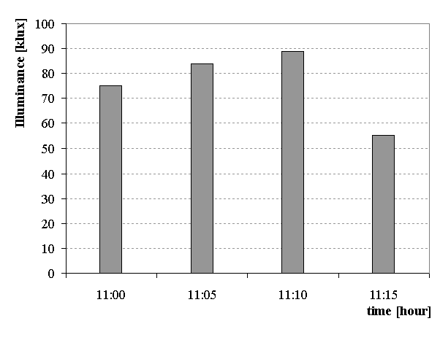
Fig. 1 Title of the figure
Tables with captions (Table. 1, Table 2, …) are centered. The table captions in Time New Roman 11 pt, with 6 pt spacing (above and below the caption) are positioned above tables.
Table 1 Title of the table
Equations should be numbered consecutively in rounded brackets. The equation itself is shifted 1 cm from the left margin.
$r=\frac{p}{\text{sin}α}$ (1)

4 Conclusion
Please send the completed paper in MS World format (Solaris_authorsurname.doc) to the e-mail: mohelnikova.j@fce.vutbr.cz. Thank you for your cooperation.
Acknowledgement
Authors' acknowledgement.

References
- Smith, H. et al Book, Publisher, City, 2005.
- Johnson, A. Article, Journal, 2010, vol. (no), 11-15.
- Brown, P., William, E. Paper title, Conference Proceedings, City, 2003, 32-36.
- Lee, D. Title, www.xxxx.com, 2011/01/25.

