TITLE OF THE PAPER (MAX 2 lines allowed)
First Author¹*, Second Author², Third Author³
¹Affiliation, Address, City and Postcode, Country
²Affiliation, Address, City and Postcode, Country
³Affiliation, Address, City and Postcode, Country
Abstract
The abstract should give a brief overview of the most relevant aspects of the paper. It is required that the abstract is structured as follows: purpose of the research, methodology, main results and major conclusions. Authors are requested to avoid using references and uncommon abbreviations in the abstract. It is essential that the abstract is able to stand alone (separately from the whole manuscript). The extent of the abstract: up to 250 words. It is important that title, authors, contact-addresses, abstract, keywords and citing instructions in English language are on the first page.
Key words
Authors have to provide a minimum of 4 and maximum of 6 keywords that best describe original content of the paper, alphabetically sorted and separated by semicolons
*Corresponding author: Tel.: +0-000-000-000, Fax: +0-000-000-000,
E-mail address: xxx@xxx.xx

introduction
The paper should be prepared for printing on paper format A4 (210x297 mm). We recommend you to use this template and insert the text here, with already defined styles and other required customizations. The extent of the paper: 6 - 12 pages including appendix.

Structure of the paper
Paper depends on its content, but authors are strongly recommended to divide the manuscript into clearly defined and numbered sections. The structure should be prepared as follows:
- Introduction (state the aim of the research)
- Literature Review (please use mostly up-to-date literature published in internationally recognized journals; only published articles/works can be used as references)
- Methods/Methodology (provide enough detailed information on research done to enable your research to be reproduced)
- Results (results must be clear and transparent)
- Discussion (explain the substance and importance of achieved results)
- Conclusion (give most important conclusion from your paper)
- References (requirements for referring other papers are given below; not numbered section)
- Acknowledgments (optional section; not numbered section)
Text text …

Figures
All figures (charts, drawings and photos) should be provided in usual format (gif, jpg, bmp), should be of sufficient quality. They are numbered according their appearance in the paper (1, 2, 3, …). Each figure should be supplied in the paper and in a separate file. References to all figures have to be made inside the text, in order to ensure connections between the text and the information from the figure.
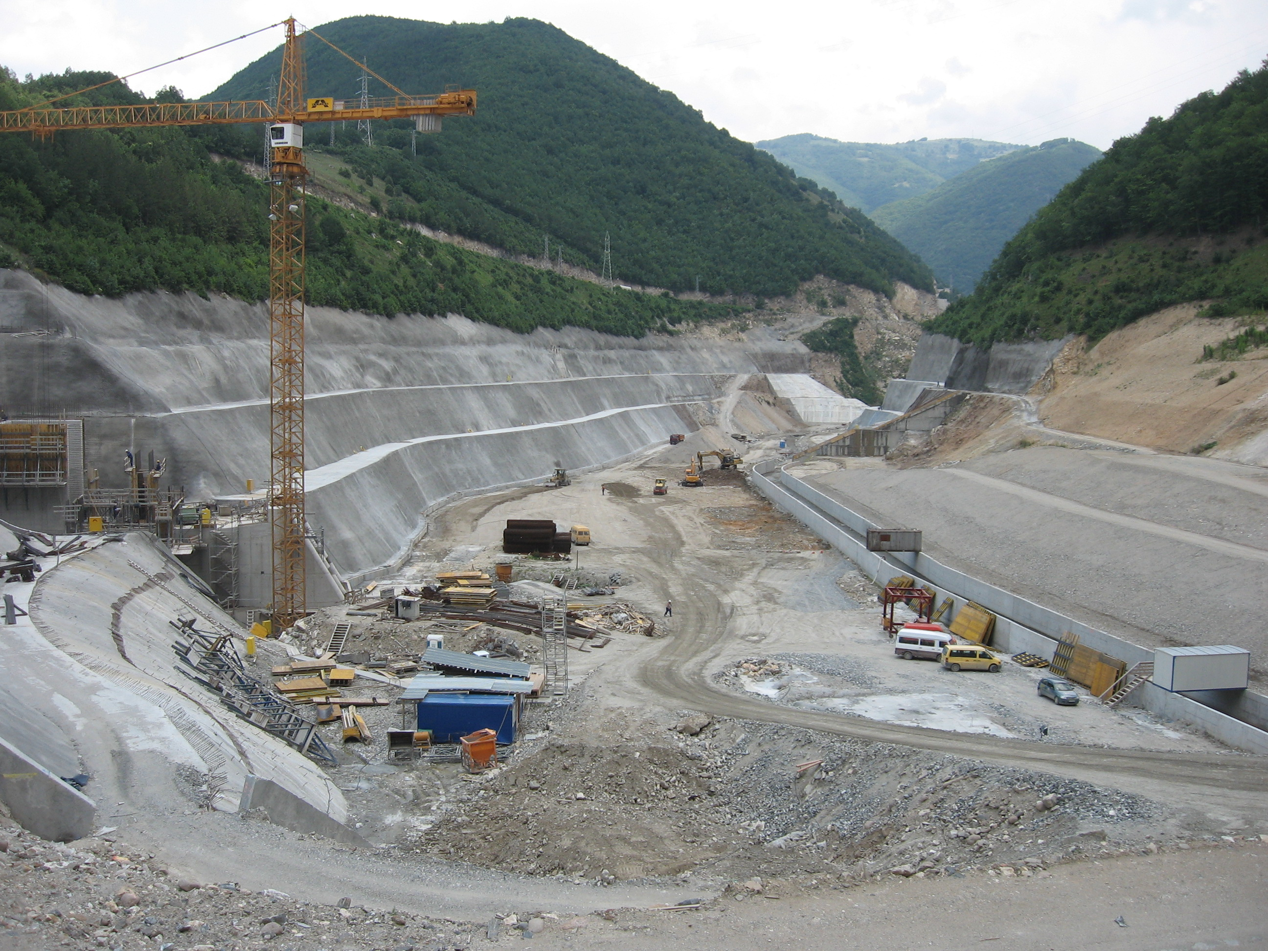
Fig. 1: Caption for the figure

Tables
Tables are constituent part of the document. They are numbered according their appearance in the paper (1, 2, 3, …). All tables should be Black & White or Greyscale. References to tables have to be made inside the text, in order to ensure connections between the text and the information from the table.
Tab. 1: Caption for the table
Parameter | Volume (mio m³) | Ponded Area (mio m²)
Max. Operating Water Level | 110,9 | 3,27
Min. Operating Water Level | 69,8 | 3,25
Dead Volume | 31,2 | 1,33

Other Requirements
Papers that are not prepared according to formatting instructions will not be reviewed and will be returned to authors for corrections.
We expect authors, reviewers and editors commit to publication ethics in order to ensure high quality of published contributions in PBE conference proceedings. PBE's Publication Ethics and Publication Malpractice Statement is based, in large part, on the guidelines and standards developed by the Committee on Publication Ethics (COPE).

Equations
Equations should be centered and numbered according to their appearance in the text.
Z = S + T (1)

Abbreviations
Use of abbreviations has to be reduced to minimum. Generally used units can be used without their definitions.

Footnotes
It is NOT allowed to use footnotes to the text.

Language
All abstracts and full papers must be written in English. English has to be of sufficient quality. If English is not your first language, it is strongly recommended to have your manuscript checked by a specialist of English language.

References
References should be brought together at the end of the manuscript and numbered in order of their appearance in the text. When reference to literature is made the publication number from the list of references in square brackets is used like "... in [4] the authors introduce ..." or "...Treloar et al. in [7] emphasises ...". The references have to appear in the text of the manuscript. Please provide URLs and DOI for the references where available. Authors are responsible for obtaining permission to reproduce copyright material from other sources.

Example of Reference List
The reference list must be also justified (left and right).

References
[1] Lominadze, D.G. (1981). Cyclotron waves in plasma. 1sted. Oxford: Pergamon Press. ISBN 0-08-021680-3.
[2] Haponava, T. and Al-Jibouri, S. (2009). Identifying key performance indicators for use in control of pre-project stage process in construction. International Journal of Productivity and Performance Management, 58(2), pp. 160-173. http://dx.doi.org/10.1108/17410400910928743
[3] Directive 2004/18/EC of the European Parliament and of the Council on the coordination of procedures for the award of public works contracts, public supply contracts and public service contracts, Official Journal of the EC, 114, 2004.
[4] Egan, J. (1998). Rethinking construction: report of the construction task force on the scope for improving the quality and efficiency of UK construction. HMSO. Available at: http://www.constructingexcellence.org.uk/pdf/rethinking%20construction/rethinking_construction_report.pdf (accessed 7 January 2014).

