
Goal: the creation of a virtual European cultural centre
Knowledge sharing among Europeans about everyday culture

Project of the European Federation of Older Students at Universities (EFOS)
September 2008 – July 2010

Contributions on the topic of housing culture

BRNO    http://www.u3v.cz/vecu  Housing culture during various architectural eras of the 20th century  - Art nouveau in architecture  - Czech cubism  - The architecture of Czechoslovak functionalism  - Traditional Czech architecture in the period between the world wars  - The architecture of social realism  - Brussels 58  - Mass housing construction in the nineteen seventies and eighties  - The possibilities for architecture in the nineteen nineties |  | DRESDEN  http://www.tu-dresden.de/senior  Housing culture in Dresden and the surrounding area during the last hundred years  - Changes to housing over the course of a lifetime  - Play  - Technical innovation  - Telecommunications  - Co-operative housing | KIEL  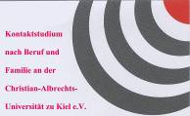  http://www.kontaktstudium.uni-kiel.de/vecu  Traditions and customs as part of housing culture in the City of Kiel and the surrounding area from around the year 1900  - During the course of the year  - The ecclesiastical year  - In relation to the family  - Questionnaires
 |  | 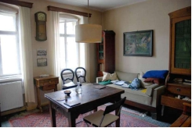 | 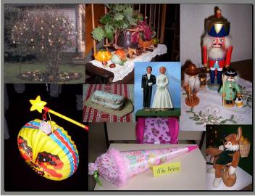
Research methods: questionnaires, personal recollections, interviews with eyewitnesses, museum visits, study of sources on the Internet, in the press and in literature, discussion circle
Questionnaire for: | - students of the faculty of civil engineering (ideas about the housing of the future) | - discussion circles with students  - afternoon games with children  - senior citizens record their experiences | Questionnaires for: | - teachers  - pupils  - students of ethnology  - older persons
Results: webpage, posters, documents, images, collections of materials, reports
Notes / experience:
- Architecture is interrelated with the given age  - The context linking architecture and social and political conditions  - Architecture reflects lifestyle |  | - The primary changes in technology transform the culture of housing  - A new understanding of the family in relation to its atomisation  - The necessity of passing down our memories to younger generations | - Project recommendations and interest in the results  - The position of customs in life  - Changing customs  - A partial weakening of traditions
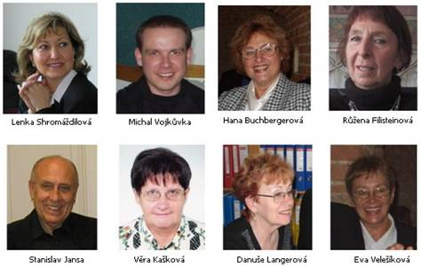  Lenka Shromáždilová Michal Vojkůvka Hana Buchbergerová Růžena Filisteinová  Stanislav Jansa Věra Kašková Danuše Langerová Eva Velešíková |  | 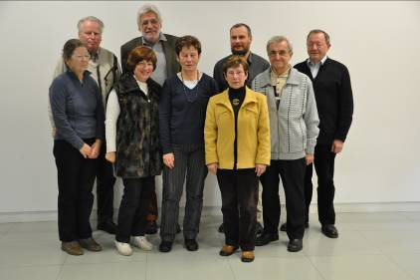  The team from Dresden | 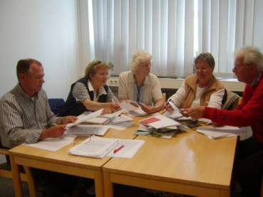  Dr. Helmut Holzlöhner, Ingrid Dummer, Grada Grootes,  Ute Rummer, Bernd Hohensee

