**BASIS FOR TECHNOLOGICAL SPECIFICATIONS FOR FOUNDATIONS**

**(Execution of foundation strip)**

**Task # 2:** Prepare the technological regulation for design of reinforced concrete foundation structure for your object, determine the cubic capacity of concrete, steel and formwork - for training purposes, determine the area of ​​formwork - classic or systemic. Below is a outline of regulation plus additional pictures and things that is needed to describe.

**1) General Information**

**1.1 General information about the construction**

- Identification of the building, for which the structure and working methods of regulation is written, building size, the building difficulty, purpose the building (building for housing, manufacturing ....)

- Separation of the building on objects,

- Location of buildings (free standing, vacant lot ...)

- Slope of the area, the conditions for foundations,

- Basement, number of floors, type of roofing,

- Material properties of supporting structures,

- General information on site facilities, underground water, radon, soil, and approaches the situation at the site, information on protected areas and protection zones and other relevant circumstances of the construction.

**1.2 General information about the process**

- Identification of the process for which the prescription is processed - i.e.. demands of process, type of process, what we are dealing with, the general characteristic of work, etc..,

- Select the type of foundation

- Type of of the reinforcement,

- Formwork,

- Concrete plant + fabrication of reinforcement.

**2) Preparedness of construction site**

**2.1 Preparedness of construction site**

- At this point, the site preparation will be described, inter-site roads, lifting mechanisms, cells for construction, dumps, etc...

- Indicate everything that will be ready from previous work and what will now build.

**2.2 Takeover workplace**

- Between the subcontractor and the main contractor or the realization of the various stages of the building (be careful not to be confused with the takeover of site which takes place only at the beginning of the construction between the investor and main contractor).

- Conditions for acceptance (completion of the previous stage), who performs and where it is written,

- Enter here the work and activities that should be completed in the previous phase and make sure everything is as it should be.

**3) Materials, transport, storage**

**3.1 Calculation of material**

- List of basic material + supplementary material with reference to relevant standards and other regulations (preferably in a table, units of measurement, the average consumption to Unit, total consumption, backlog, packing).

- Calculate the cubic volume of concrete and steel weight (1 m3 of concrete contains approximately 150 kg of steel), as well as classical area of formwork (+ write what constitutes - boards, beams, stay bars, bailing wire) and do not forget the additional material (eg. Spacers, etc. .).

**3.2 Transport**

***3.2.1. Primary transport***

- You solve transportation of materials for construction. By trucks:

- Material for the formwork and reinforcement (reinforcement must not be damaged in any way transportation).

- Concrete will be imported from concrete plants by mobile concrete mixer. Count the number of concrete mixers for that there is continuously work. (of course there is the possibility of concrete production on site, but is not used in such extensively).

***3.2.2. Secondary transport***

- Secondary transport solves transport of materials in the construction site - i.e.. Transport of material for the construction from the places of production to the place of his of processing - classic material for the formwork, reinforcement, or additional small material (nails, etc..).

- Transport of small things will be handmade, using pails or by crane (reinforcement).

- Also consider concreting. It can be performed by using concrete pumps or directly from a truck mixer (or production of concrete on site).

**3.3 Material storage**

- Storage of simple materials - Solve using cells, storage of the reinforcement to paved and drained area with wooden beams (identified by its label). Furthermore, storage of materials for classic formwork.

**4) Working conditions**

**4.1 General working conditions**

- Preparation of the workplace with connection to use of construction site buildings (electricity, lighting, editing places - dumps, access roads) - deal only generally

- General working conditions, such as: temperature, requirements to work in the winter, the required weather conditions, requirements for previous work

- All conditions whose failure would affect the final operation, briefing of staff.

**4.2 Working Conditions of process**

- Preparation the workplace with connection to use of construction site buildings (energy, lighting, editing places - dumps, access roads) - in relation to the process solves the same points as above, but in relation to the implementation process, i.e.. Need to consider the specific requirements with regard to the materials and technology.

**5) Technological prescription (**[**sequence**](javascript:r(1))[**of**](javascript:r(4))[**operations**](javascript:r(5))**)**

- Chronological sequence and description of the operation with complete technical data to show a clear process works - i.e.. "Cookbook" of the work,

- The necessary steps that must be taken after the shift and after the procedure

- Under what conditions is done out inspection, who performs it and how it evaluates and records the result.

In general, this chapter will be divided chronologically the following steps:

- Manual cleaning of the excavation, Thickness 10cm,

- Creating a blinding concrete (thickness depending on the project, possibly also base layer from the compacted gravel)

- Technological pause (solidification of concrete)

- Alignment of the foundation structure,

- Execution of classical formwork (by carpenters)

- Vertical, horizontal ledges, anchoring, stabilizing,, inserting of the reinforcement, formwork top

- Placing of reinforcement

- Execution of other side of formwork

- Concrete Pouring and curing of concrete,

- Technological pause,

- Removing the formwork

**6) Staff (group of workers)**

- Solve the composition of the working group for the the implementation of the foundations, shall be entered here:

- the master - (!! no construction manager, but the champion and the most experienced person in the squad, or the person or with the most appropriate permissions to perform specific work,

- Composition of the work crew, the number of workers in various professions, do not forget to machine operators,

- Indicate required qualifications of individual workers

- Duties and responsibilities of individual workers.

**7) Machinery and equipments**

**7.1 Necessary machines**

- Design solutions necessary machines - heavy machinery required for the execution foundations.

- Consider trucks to transport materials for construction

- Furthermore mixers for transporting concrete from the concrete plants

- Concrete pump for concreting.

**7.2 Required tools and equipment**

- This section solves necessary electrical and mechanical manually tools needed to do the work - is needed for the number of pieces of electrical equipment

- necessary equipment - shovels, spades, buckets, hammers, etc.. performance for the the stage - the number of pieces is unnecessary, it is a commonly available tools and equipment on site.

**7.3 Required and recommended personal protective gear and equipment**

- This section solves required and recommended personal protective equipment and tools for the technological stage - helmets, vests, work clothes, footwear, work becket.

- Tools are aimed to safety.

**8) Quality control and Checks**

**8.1. Input control**

- Determination of partial takeover of previous works which will be covered by subsequent works, takeover previous works - i.e.., For example, the footing bottom takeover before starting work on the foundations (flatness, dimensions, strength, etc..)

**8.2. Interoperation control**

- Technical data and information that are required for the result of the activity and checked in during the construction and implementation of the phase,

- The required inspection and testing during running of work - eg. Controls of formwork design (composition, accuracy), etc..,

- Documentation of performed tests, who performs them, as is done and where the are recorded

**8.3. Output control**

- Technical data and information that are required for the result of the activity and which are checked at the end of the construction and implementation of the phase,

- The required inspection and testing running after completion of the work - eg. Controls of formwork design (composition, accuracy), etc..,

- Documentation of performed tests, who performs them, as is done and where the are recorded

**9) Health and safety**

- Government Regulation no. 591/2006 Coll. Detailed minimum requirements for safety and Health at work on construction sites,

- Government Regulation no. 362/2005 Coll. Detailed requirements for safety and health at workplaces with risk of falling from height and the depth,

- Government Regulation no. 378/2001 Coll. Laying down detailed requirements for safe operation and use of machinery, technical equipment, instruments and tools,

**10) Ecology - environmental impact, waste management**

- During construction arise in terms of law no. 185/2001Coll. and no. 381 / 2001Coll. wastes such as: - 17 02 01 O Wood

- Code can be found in the Waste Catalogue no. 381 / 2001Sb. under the category number 17 - Construction waste). Write a main waste for the the stage (foundations).

**11) Literature, technical norms, www page**

**APPENDIX No.1**

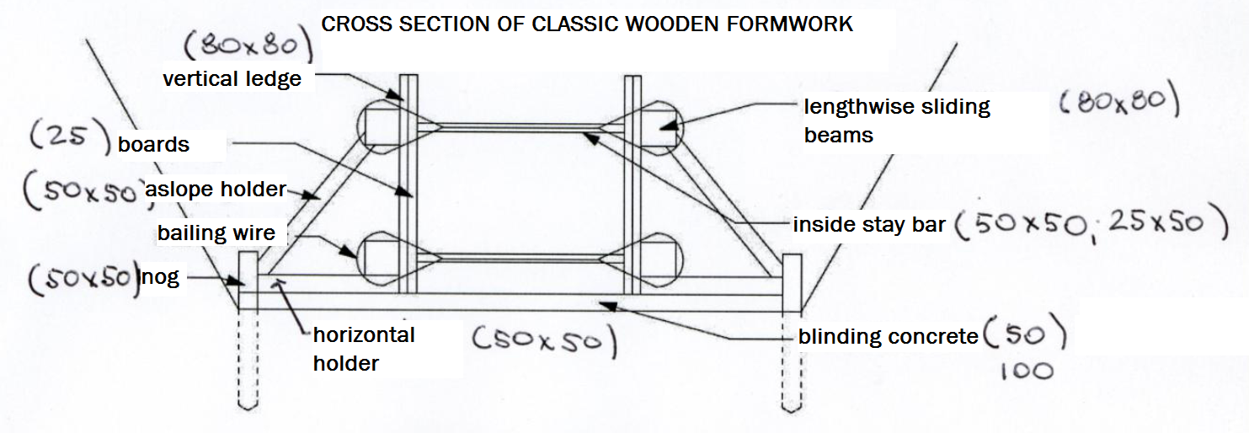

**APPENDIX No.2**

